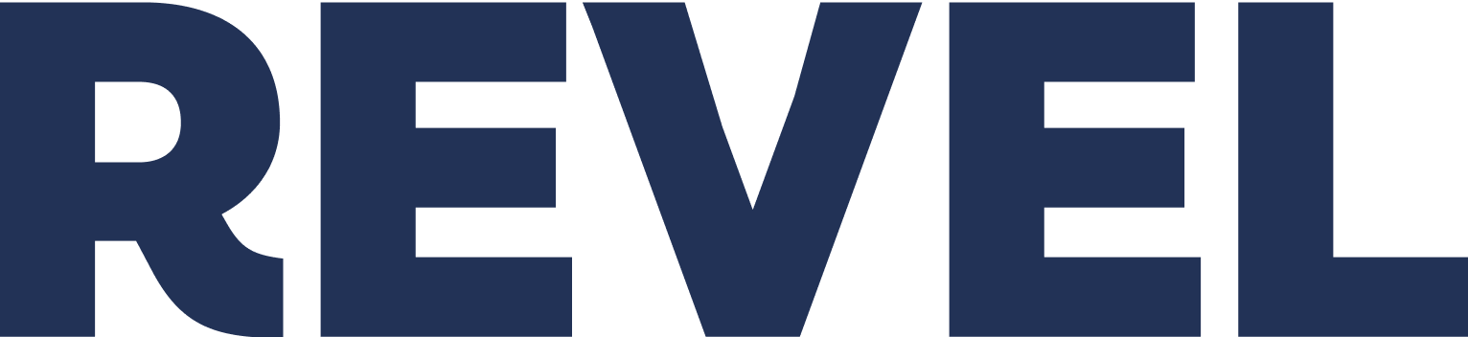

DRAFT FOR REVIEW
About Us

The following web page copy draft assumes a scrolling page and takes into consideration best practice approaches for engaging About Us pages, converting a historical narrative into a customer-centric, conversion-focused experience. It hits the marks that most About Us pages miss when it is just about the story. Successful About Us pages engage the visitor/potential client by engaging what you can do for them in the narrative.
Specifically…
- It leads with the customer’s pain and aspiration.
  - Don’t start with history. Start with statements that center on the customer’s emotional frustration, then move into “Why we exist”
- It focuses on the “Why?” and “Why Us?”
  - It defines the aspirational mission
  - It declares the team’s core commitment
- It uses the CSD story as trust and proof—not as the main point.
- It uses the history to underscore character
- It avoids jargon
  - The language is warm and accessible. Eg, “...our heart center remains the same
- It clearly defines value and a solution
- It answers “What can you do for me, my child, our family?”
  - The answer: Breakthrough ABA with a unique approach for your unique child.
- It emphasizes CSD’s differentiators.
  - Explicit that CSD “is not just another ABA provider.”
  - The combination of “rigorous science” and “compassion, empathy, and heart.”
- It provides strong, dual calls to action (CTAs) with a powerful, engaging, enticing lead-in—ensuring every visitor to the page knows exactly what to do next..
  - “Ready for a breakthrough?”
  - “Launch Your Child’s Future”
  - “Elevate Your Career”
- The use of strong headings makes the page highly scannable—essential for busy, frantic, distraught, and emotional caregivers needing help.

[About Us Page Copy Draft]

Every Child Should Have the Opportunity to Reach Their Fullest Potential

We believe every child with autism deserves a future defined by possibility, not limitations. For too long, autism services have been emotionally frustrating, confusing, and complicated: hard to access, overly clinical, and lacking the human connection families so desperately need.

We created CSD to change that and deliver next-level ABA therapy as the architects of possibility for children and teens with autism and for our dedicated clinicians, therapists, and professionals who serve them—standing at the intersection of compassion and evidence, where human connection meets clinical excellence and empathy drives innovation.

Our team is wildly relentless and committed to realizing the future you envision for your child and your family’s success.

Simply put, your child’s progress is our purpose.

_____________

OUR STORY
Born from Belief, Built on Success

CSD began in response to a need.

In 2012, when Kaiser Permanente urgently had to provide ABA therapy services for 80 families in Northern California, a small but determined team said yes—and figured out the “how” together. That scrappy, all-hands-on-deck spirit of serving families, no matter what the challenge, still pulses through everything we do.

We’ve grown up since then. From our beginnings in one Vallejo, California, clinic with a handful of passionate clinicians, we now serve thousands of families nationwide through in-home, center-based, school-based and virtual immersion therapy programs.

Today, our innovative approach to therapy is more advanced than ever, but our heart center remains the same.
_____________

WHAT WE DO
Breakthrough ABA Therapy for Your Unique Child

CSD is not just another ABA provider. We provide breakthrough autism therapy that opens up your child’s potential.

Our program is clinically grounded yet individually tailored. We start with your child’s unique needs and focus on what truly lights them up. Our approach provides the highest standard of care, where rigorous science is delivered with compassion, empathy, and heart.

CTA Button: Schedule a Call to Learn More
_____________

[Pull Quote - Placement flexible]
We are the support system for the caregiver who feels alone,
the advocate for the misunderstood child,
and the career partner for the clinician who seeks to maximize their impact.

_____________

Therapy only works when it works for your family

- Accessible Everywhere. We meet you where you are. Our therapy services are available in-home, at local centers, in schools, or via our advanced virtual immersion therapy.

- Using the Power of Virtual Reality. Through our virtual program—always with a live-on-screen therapist—we apply personally tailored, highly engaging technology as a safe space for learning to navigate the real world.

- Celebrating Every Step. We partner with you to grow skills, celebrate progress, and make the future you envision possible —one child, one family, one breakthrough at a time.
_____________

WHO WE SUPPORT
Building Partnerships for Better Care

We understand that autism impacts the entire family unit, not just your child.

- The Caregiver
Who feels isolated or alone on this complex and emotional journey. We bring hope, joy, and a clear roadmap to guide you.

- The Misunderstood Kiddo
We are fierce advocates working to release their potential and help them thrive.

- The Clinician
Who seeks a career partner dedicated to helping them excel and maximize their impact through professional growth, team creativity, and valued rewards.

Is your family ready for a breakthrough?

CTA Button: Launch your child’s future

Are you a clinician ready to elevate your career?

CTA Button: Join Our Team
_____________

[Footer FPO – needs defining]

Tagline: [CSD logo + social buttons + accreditation badges]
Services | Locations | Careers | Contact | Request Services | ↓↓

About | Privacy Practices | Privacy Policy |

Contact: (877) 910-6538 | info@csdautismservices.com

© 2025 Center for Social Dynamics. All rights reserved.

